**Module-6: Ansible Assignment - 5**

You have been asked to:

● Create a new deployment of ansible cluster of 5 nodes

● Label 2 nodes as test and other 2 as prod

● Install java on test nodes

● Install mysql-server on prod nodes

Use Anisble roles for the above, group the hosts under test and prod

Create one master and 4 slaves node

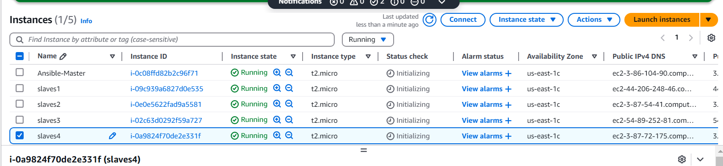

Take key on the master machine will be created by key-gen

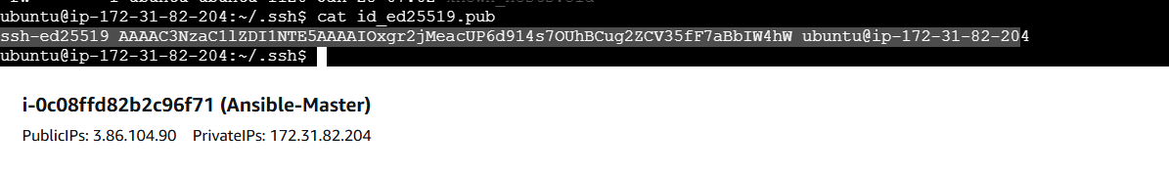

And add to all slaves:

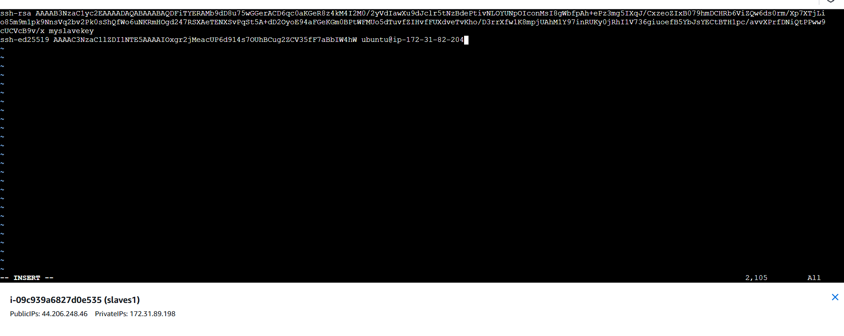

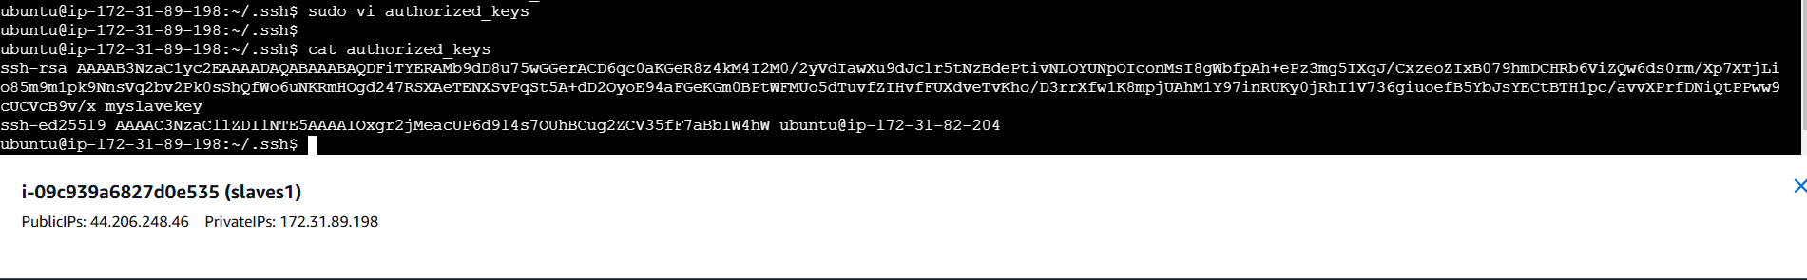

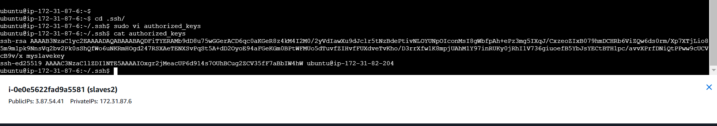

-------------group test and prod is created and added 2 instances slave in each

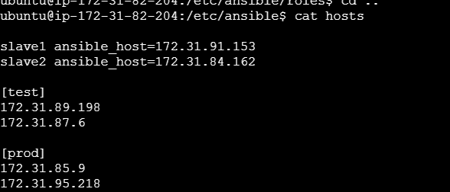

created role java and mysql

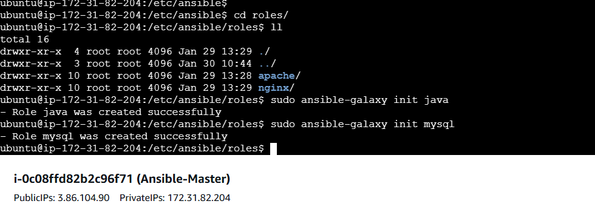

Create the install.yaml with java installation instruction on test machine

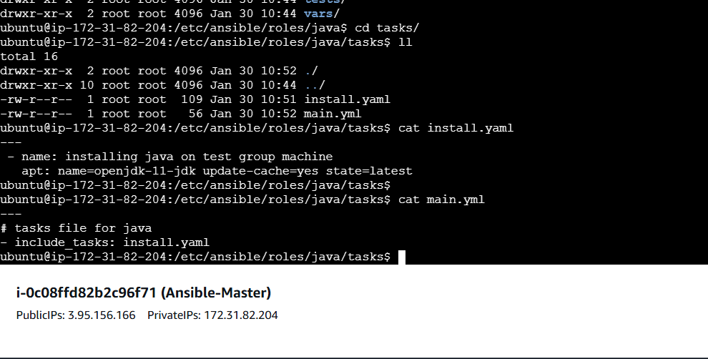

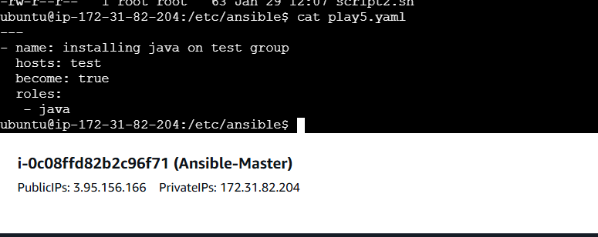

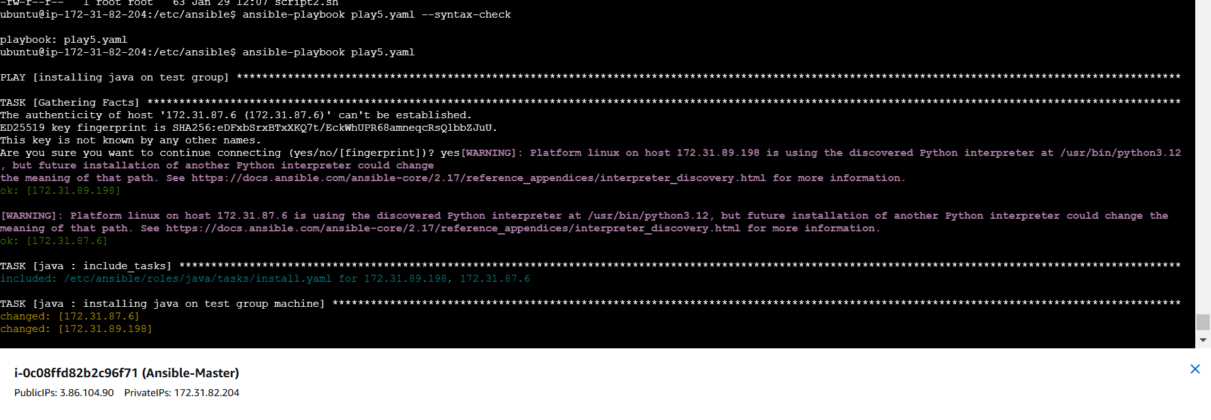

Verified On slave1 and slave2 java installed





For the 2nd group installing mysql on prod group

